Use Case
for
Smart Attendance System

Version 1.0 approved
Prepared by <Arbab Ahmed >
<ASH Solutions>
<25/4/2018>
Revision History

Name | Date | Reason For Changes | Version
Add geo-fence case | 25/4/18 | Initial | 1.0

Use Case Identification

Use Case ID
UID-001

Use Case Name
- Add geo-fence location

Use Case History

Created By

Arbab Ahmed

Date Created

25/April/2018.

Last Updated By

Arbab Ahmed

Date Last Updated
28/April/2018

Use Case Definition

Actor
- Owner of the office/site.

Description
End user(owner) of the Application interacts with this app to add new geo-fence location.
The geo-fence should add successfully and a notification is generated.

Preconditions
- Owners identity has been authenticated.

Postconditions
Describe the state of the system at the conclusion of the use case execution. Number each postcondition. Examples:
- Geo-fence has been added and updated in the database.
- A notification has been sent.

Priority
HIGH – since this is one of the core features of the application.

Frequency of Use
High

Normal Course of Events
- Add geo-fence use case is initiated by the end user
- Ask for Latitude
- Ask for Longitude
- Ask for name of the location
- Ask for radius
- Add geo-fence
- Notification is generated

- BASIC FLOW DIAGRAM:

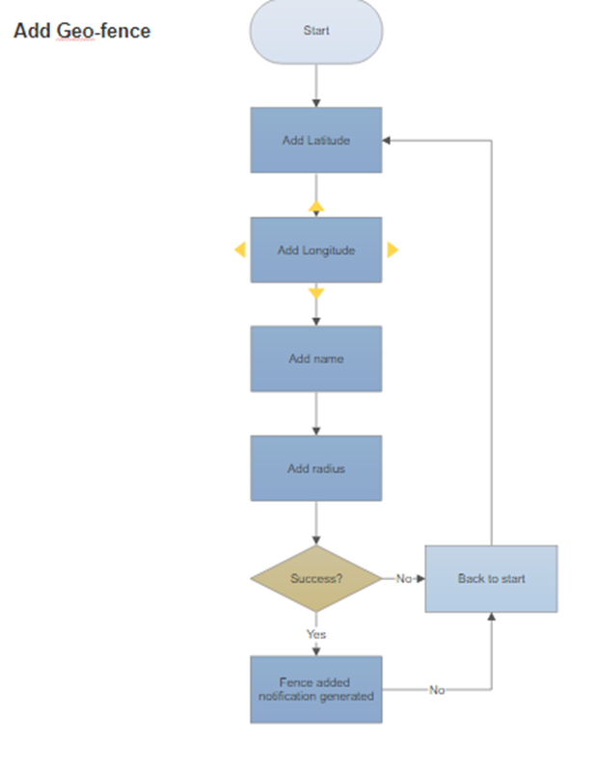

Use Case Diagram

System Boundary

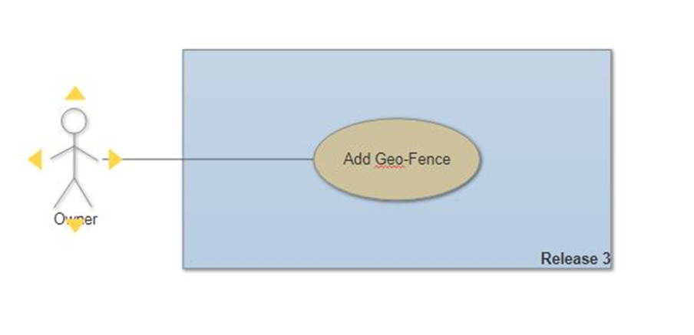

Related Information

Special Requirements
- System shall provide login module

Assumptions
- Owner is already registered and logged in by his/her account
- Device has an internet Connection

UI information

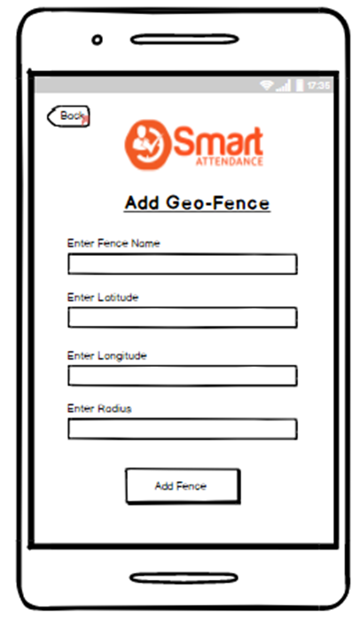

Use Case Template
Use Case ID: | 01
Use Case Name: | Add geo-fence
Created By: | Arbab Ahmed | Last Updated By: | Arbab Ahmed
Date Created: | 25/April/2018 | Date Last Updated: | 28/April/2018

Actor: | Owner
Description: | Owner can add new geo-fence location
Preconditions: | Owner is logged in
Postconditions: | New geo-fence location is added
Priority: | High
Frequency of Use: | High
Normal Course of Events: | As shown above
Special Requirements: | owner shall be logged in
Assumptions: | Device has an internet Connection

